**Advanced Software Engineering**

**CS5551 Lab Assignment- 1**

**Student Name:** Sumanth Koushik Kalli

**Student ID:** 16158017

1. **Design the Class Diagram/sequence diagram for the in class exercise on Jan 21 2014.**
2. The following diagram shows the class diagram for the Home security system mentioned in the given problem.

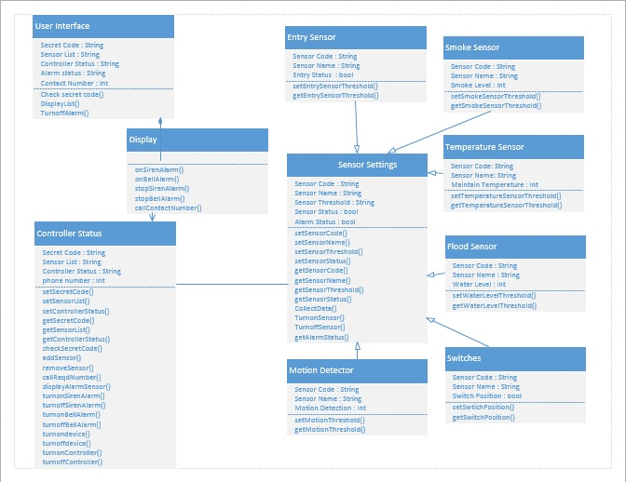

1. The following two diagrams show the sequence diagram and the flow of the proposed solution for the mentioned problem. This is drawn in response to how the program responds to alarm being triggered.

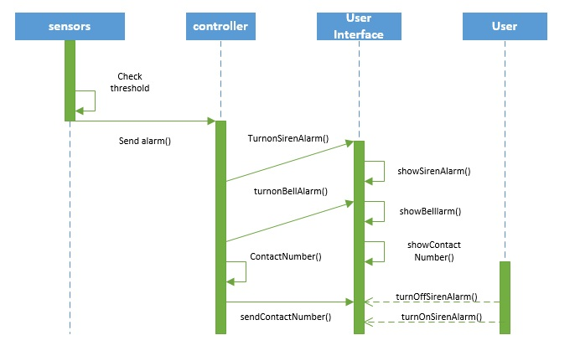

The following diagram shows the sequence diagram on how an operator can turn off the system.

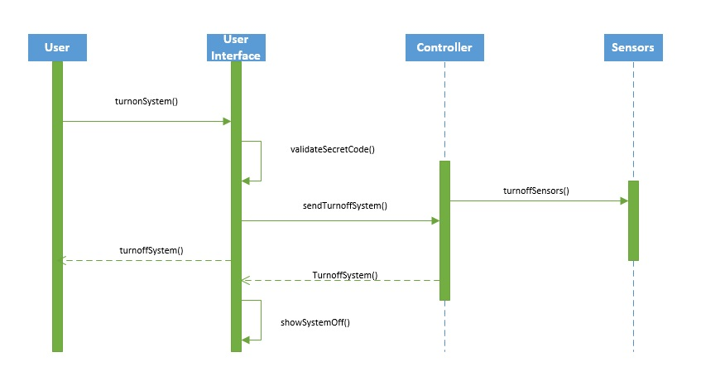

1. **Create a Github account and post Github ID to Lab 1 site**
2. Open the Github.com and create an account if you are not having one.



1. Login into your account using your username and password

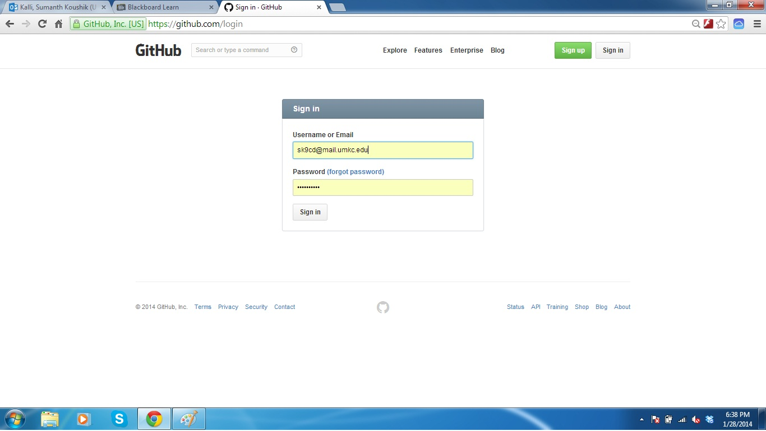

1. The following screen will be visible after you login and then you have to synchronize your files and folders from the local machine to be visible in you online account. In this example I am creating the Advance software Engineering file in my Github account, which is shown in the account.

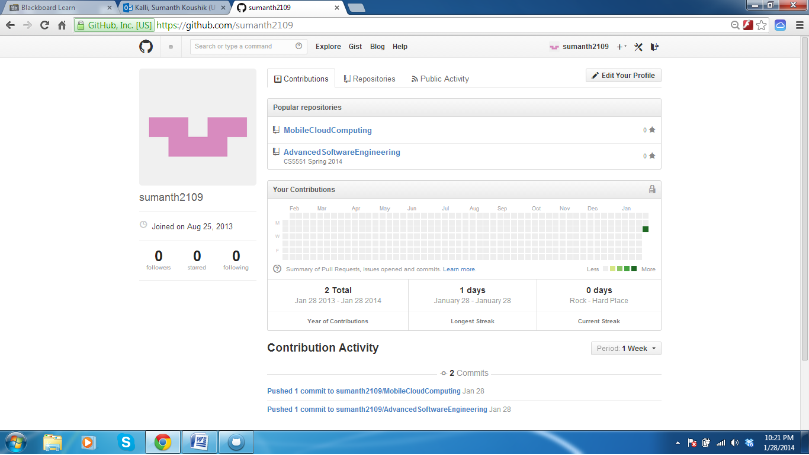

1. **Create ScrumDo account and also create stories in it about the Lab assignment 1**
2. Create your ScrumDo account from scrumdo.com as shown below.

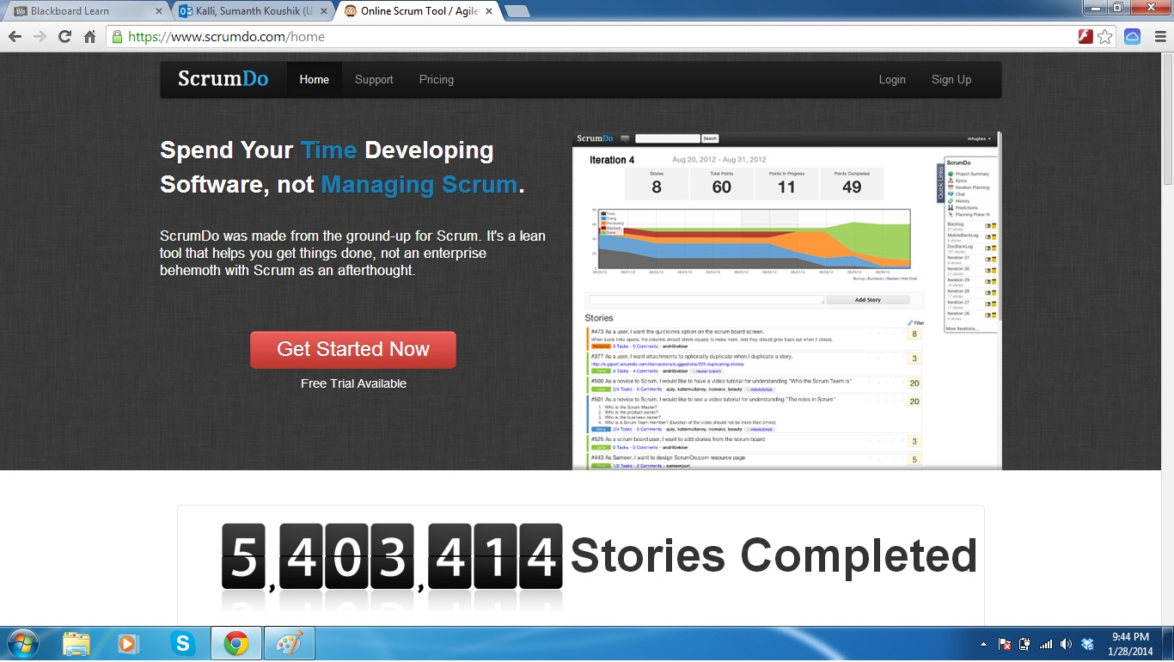

1. Enter into your account using the login credentials. 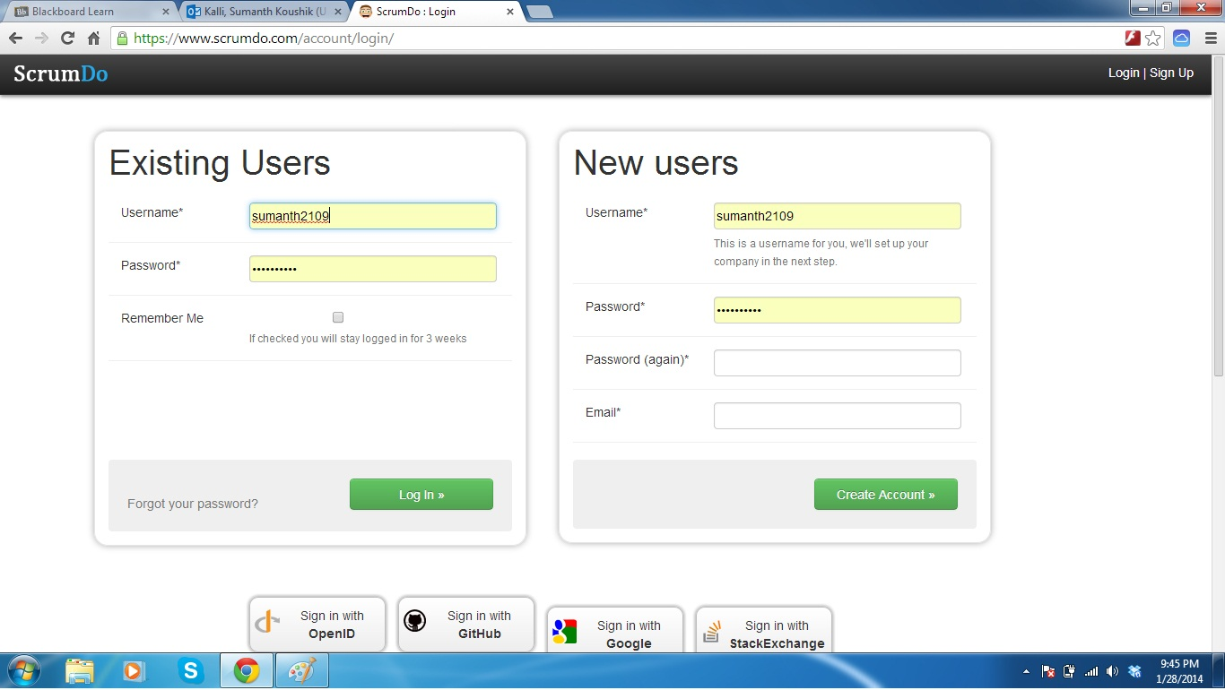
2. After entering to your account, you can create organizations in your account and then in each organization and also can create projects in organizations as shown below:

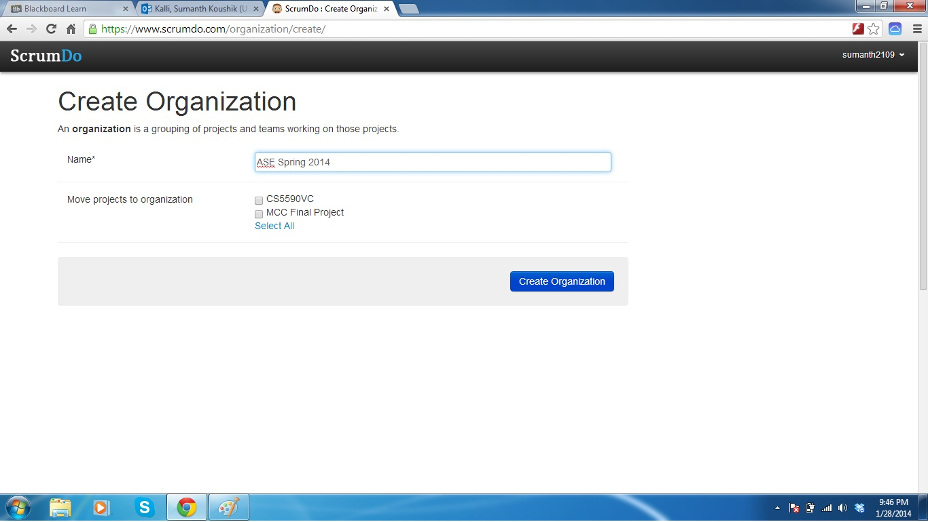

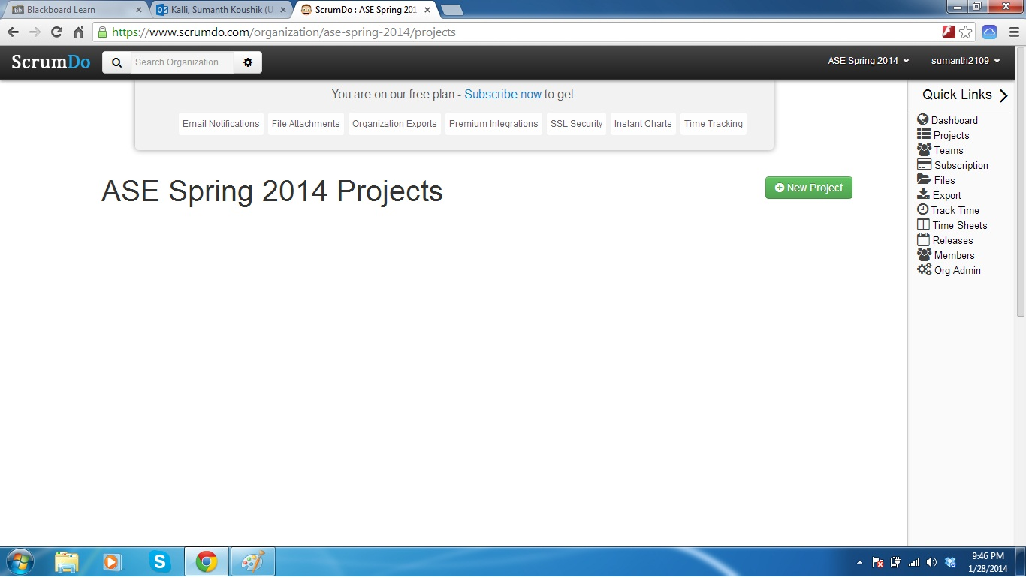

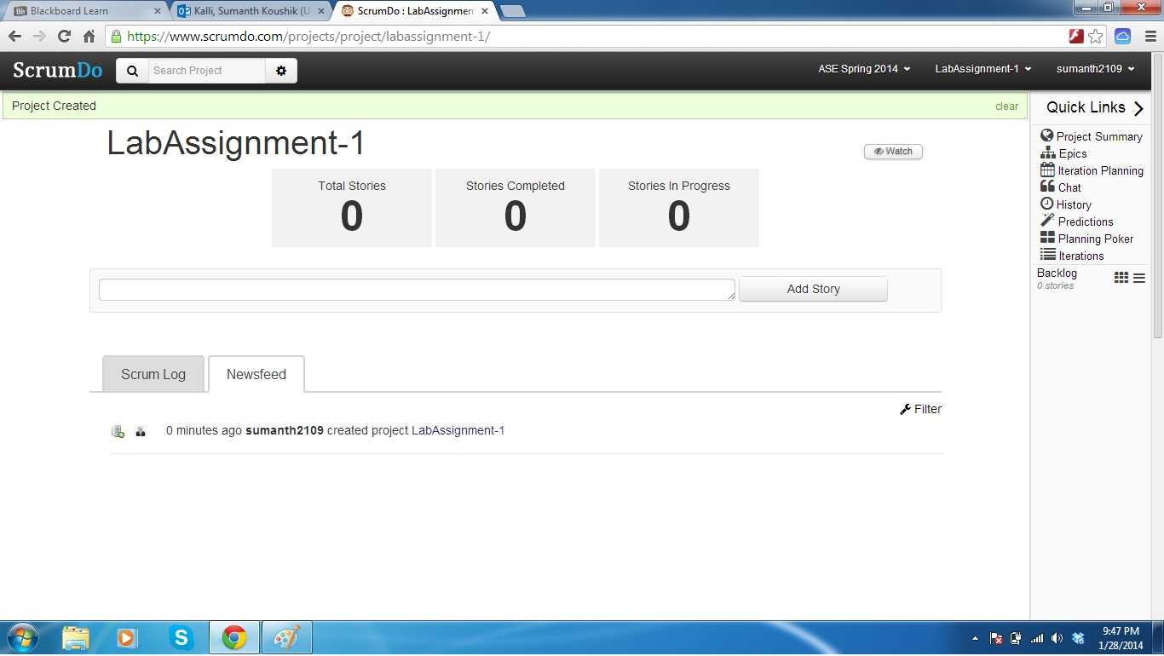

1. In your project, you can create stories and include the tasks to be done in each story. You can create multiple stories as shown in the below screenshots. The stories can be tracked in the Scrum board for your project.

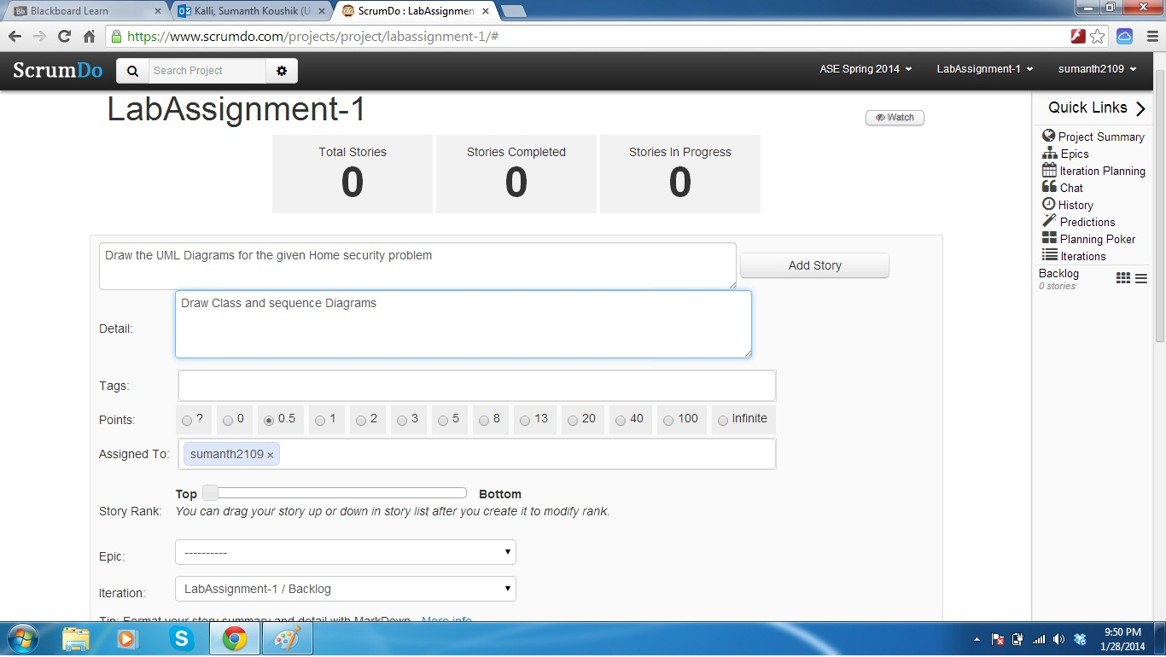

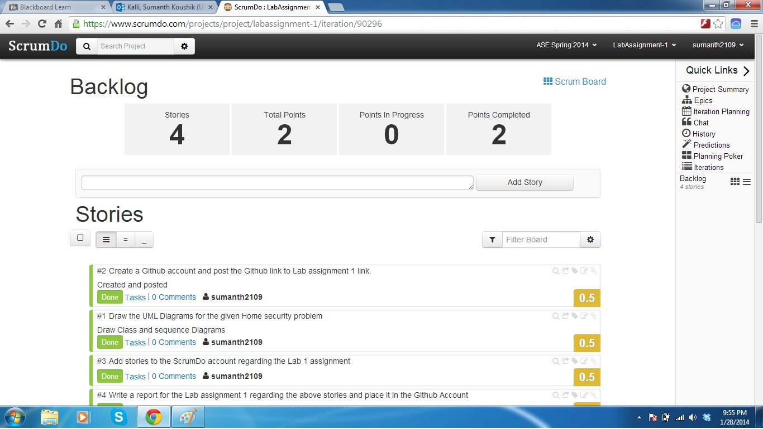

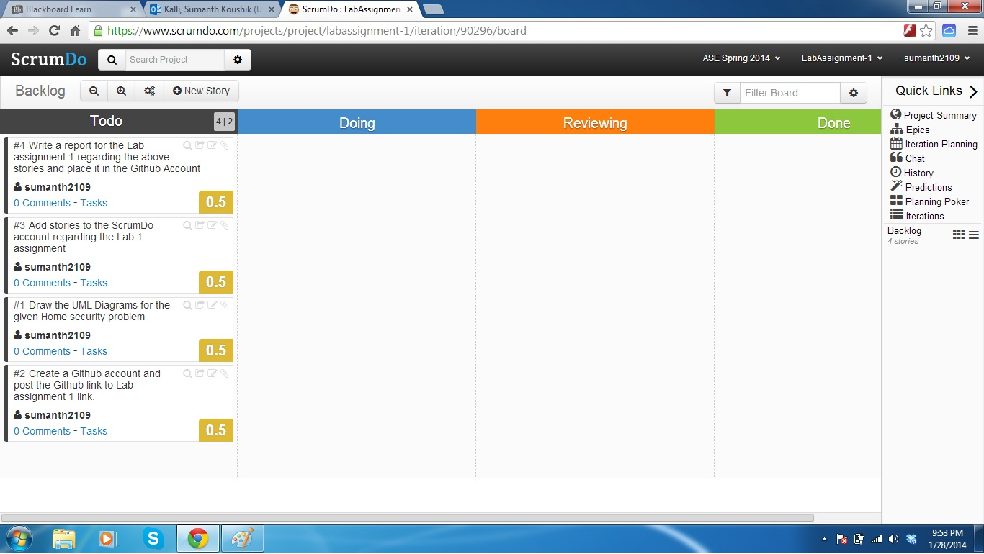

1. You can change the status of your stories as the work proceeds and after you complete each phase of the story, it should be changed to the above seen states. This is indicated clearly in the below screen shots.

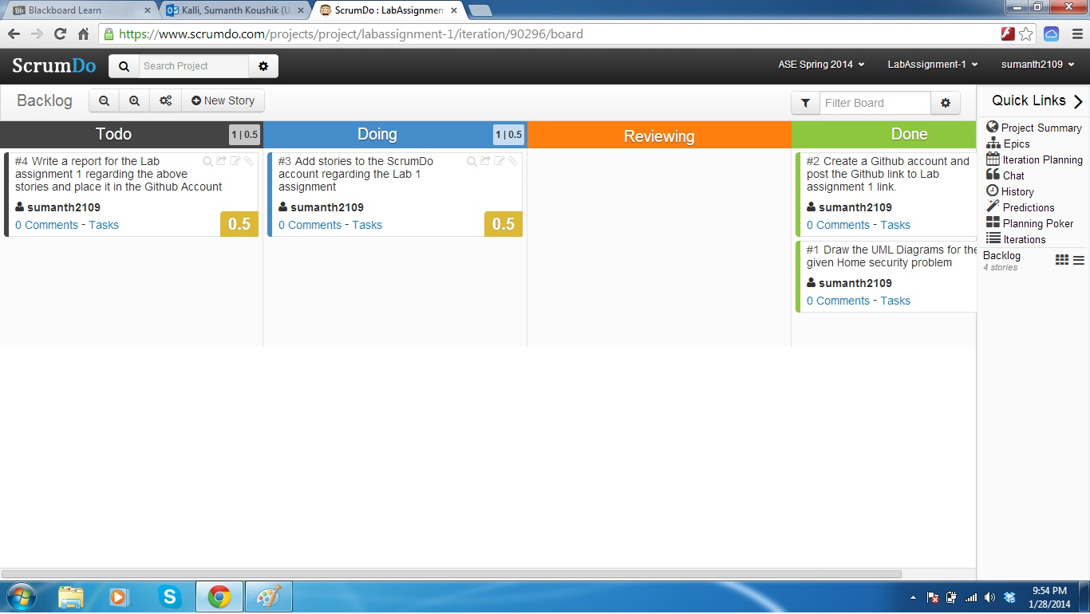

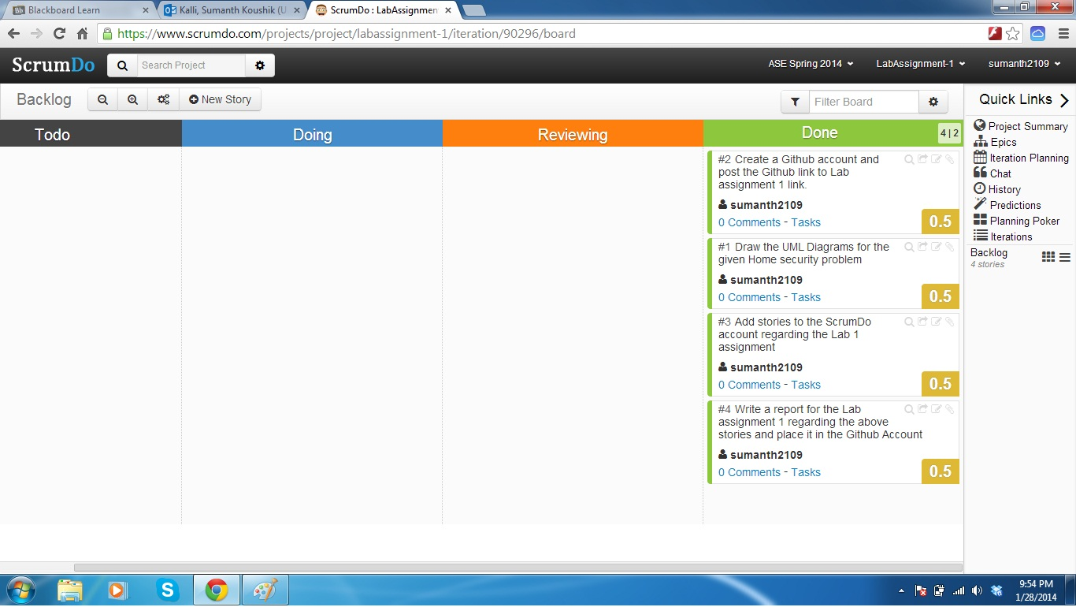

1. You can plan the schedule of completion for the stories using the Iteration planning and then schedule when to go back and see the story again. The following screenshot shows you the typical Iteration planning

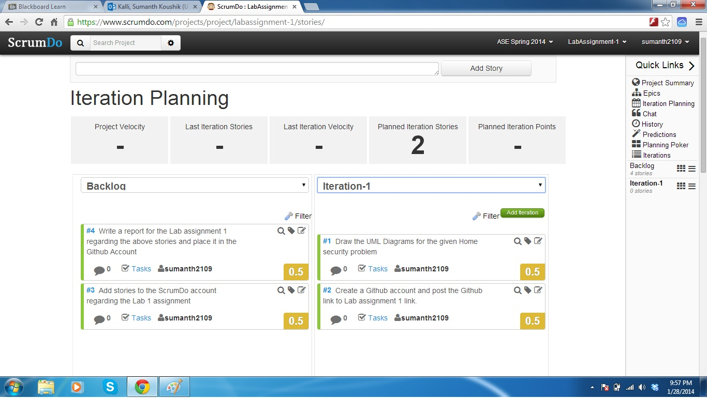

1. Epic’s can be created in your ScrumDo account and they can be seen as below:

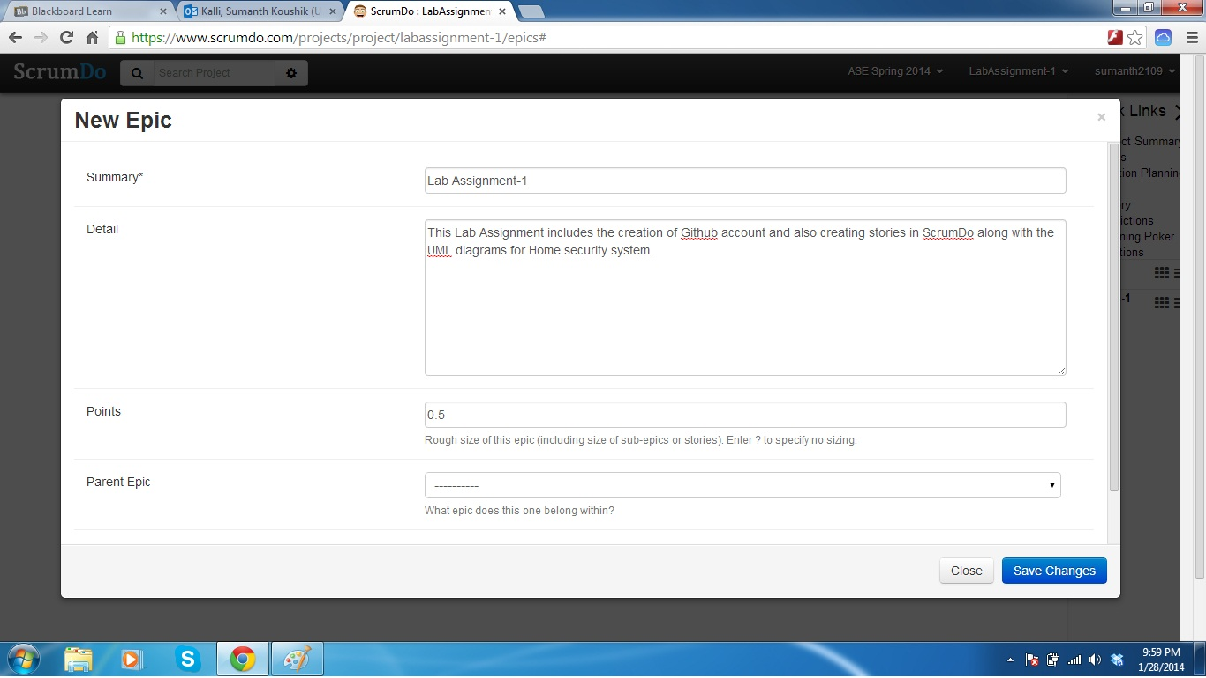

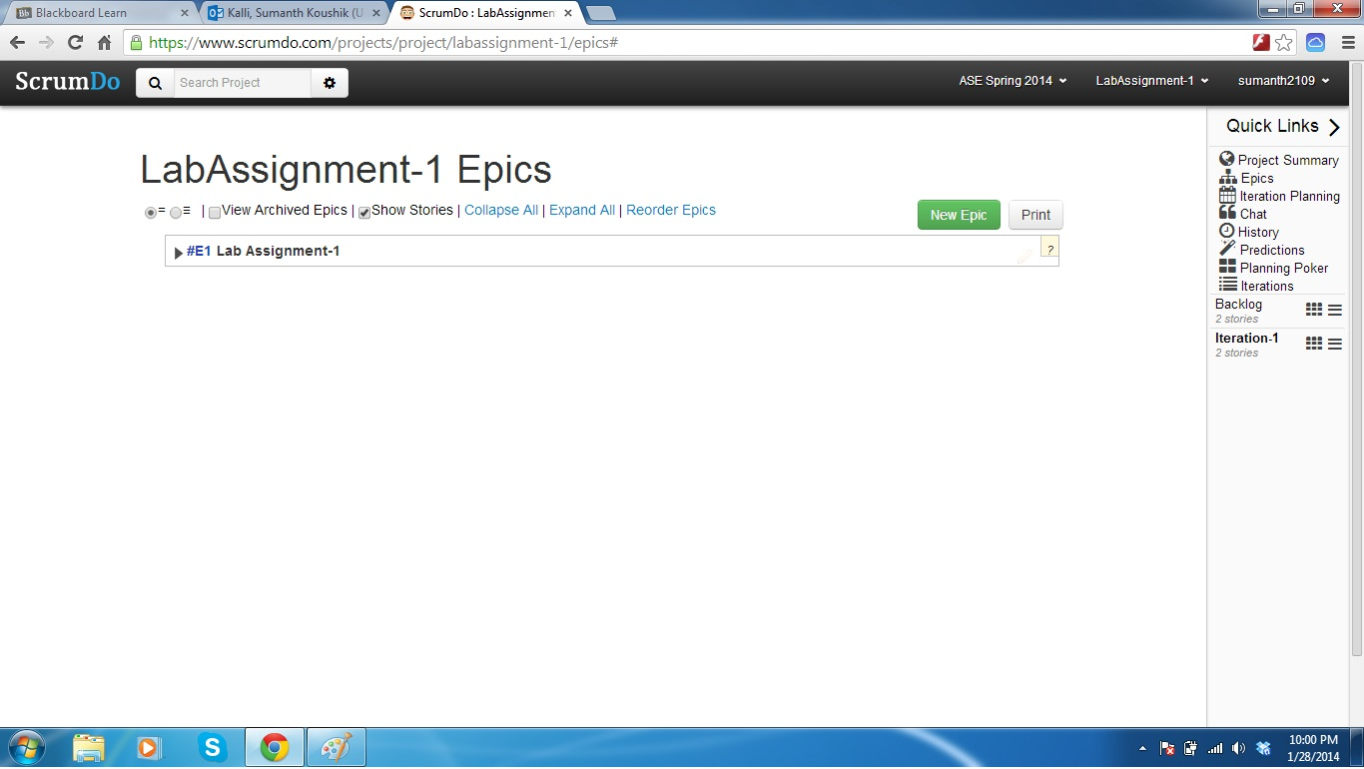

1. You can also work in teams and manage your work in ScrumDo by creating teams and inviting team members using their ScrumDo Username or email address. The following screenshots shows a typical team scenario in ScrumDo

